<HW2. SVM Report> 2015310884 박소현

**1. Code Explanation**

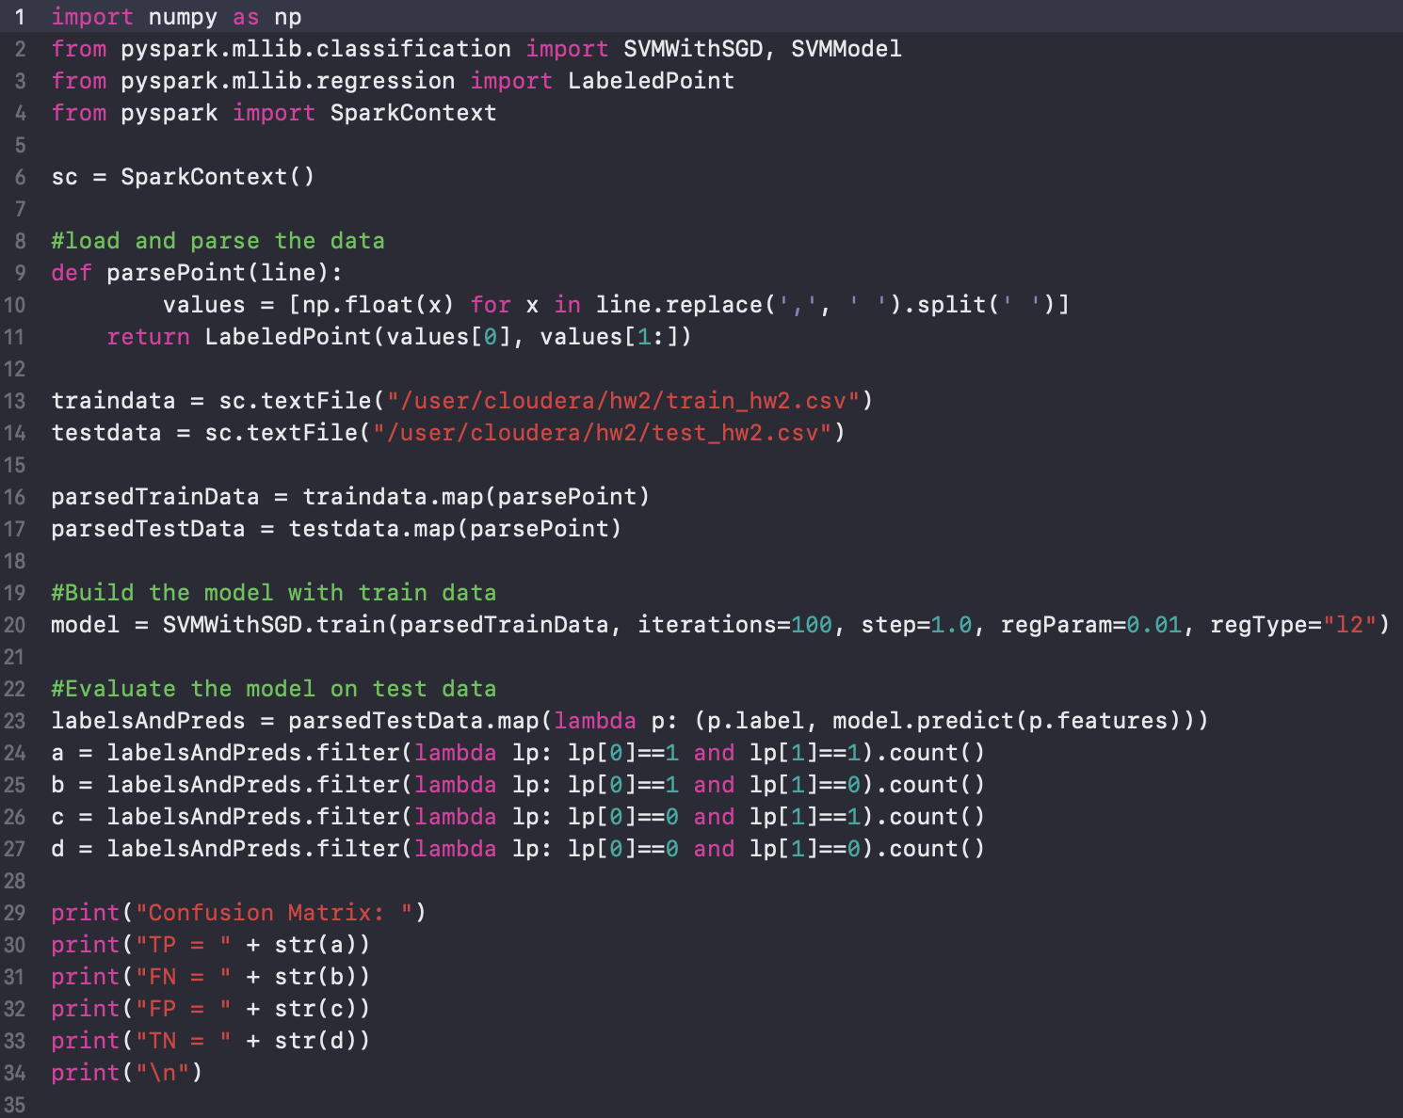

19-27: I built the model with train data, and compared label with prediction on test data for making a confusion matrix.

I divided into four cases. lp[0] means label(actual class) and lp[1] means prediction(predicted class).

① lp[0]==1 and lp[1]==1

② lp[0]==1 and lp[1]==0

③ lp[0]==0 and lp[1]==1

④ lp[0]==0 and lp[1]==0

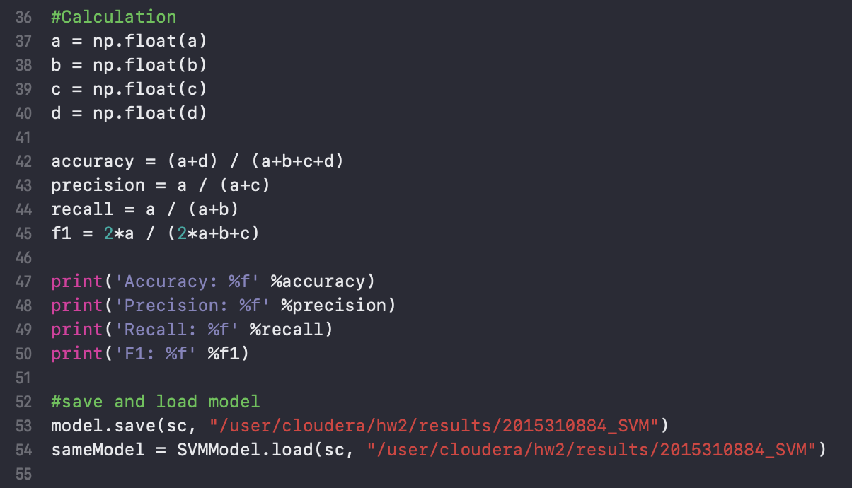

36-45: I calculated accuracy, precision, recall, and f1 with above formula.

**2. Results**

The results came out below picture.

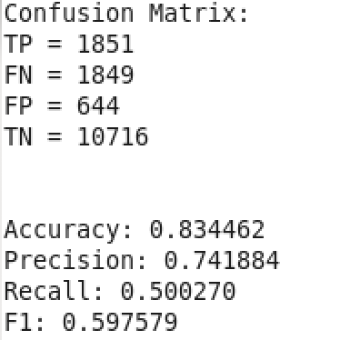

The confusion matrix can be expressed into table.

|  |  |  |  |
| --- | --- | --- | --- |
|  | Prediction | | |
| Label |  | 1 | 0 |
| 1 | 1851 a(TP) | 1849 b(FN) |
| 0 | 644 c(FP) | 10716 d(TN) |

With above results, accuracy, precision, recall, and f1 can be calculated. Formula is in the python code.

Calculation results came out.

